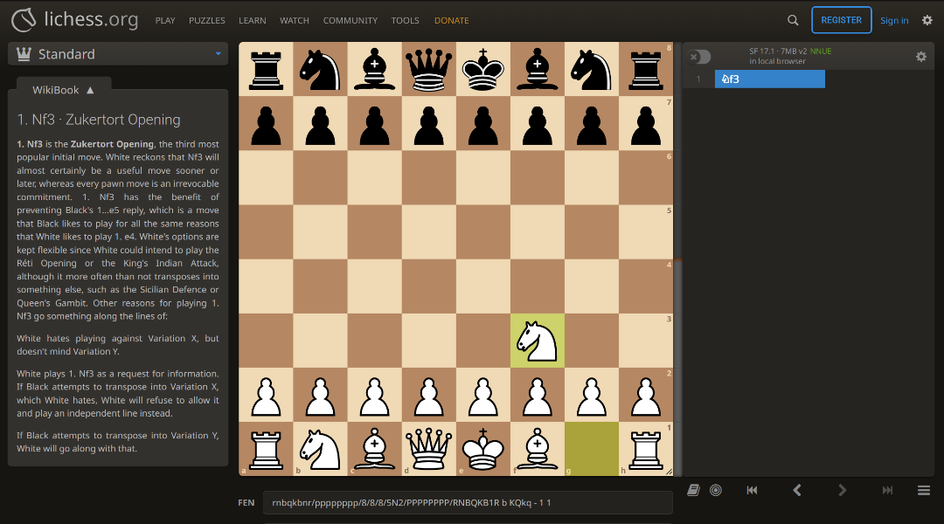
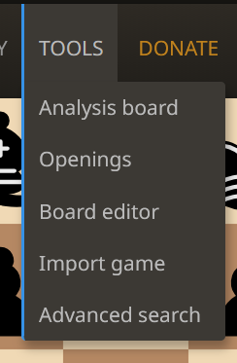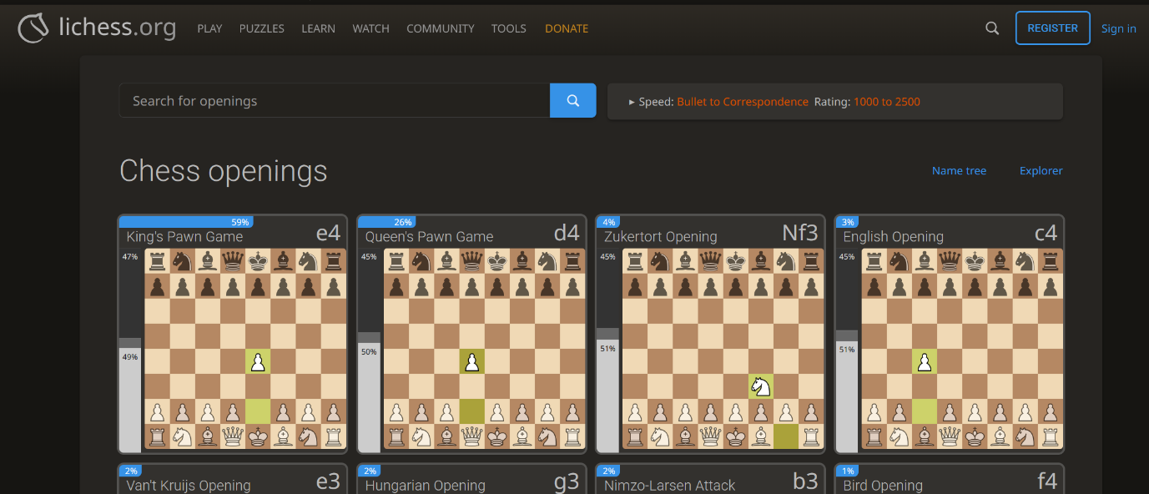
This gives a very detailed look of the move you have made and makes life easier for the teacher as they can rely on this to help explain why this move is good and give some backstory to the move and what it can lead to and get down to the grip of what this move archives. This also helps the students who can use this to help understand what that moves are and why it is a good move.
This is very useful for importing game states to the board to easily teach other concepts in chess like pining by simply importing a board from a file on your computer.
The board is quite easy to see and is at the centre of the board and is very visible to people in the classroom. Which is quite easy for students to see from the back of the class but there are no grid references on the board which is the only downside I see of it.
This is used to edit the board position easily which is quite good to make new boards to learn from and export boards to save them for later to use
Analysing board is quite useful as you want to know why that move is good or bad and what it can lead to while you are being taught. Which is good for teaching as when the teacher needs to explain it better or don’t quite understand it themselves, they Can got here and get more info on the board and that move.
This board makes life quite easy for the teacher easily making them pick openings that are well known to help teach the students and Lichess also has this for mid games and end games which makes it amazing to pick already made moves to help teach and show them off. This is used quite good when you need something quick to teach and its all already organised and students can also go on here as well to learn as well on there own and carry on where the teacher left off.

